Glen of Imaal Terrier Association Open Show  
9th June 2024  
  
Judge: Rob Jones (Silverluka)  
Special Award Classes  
  
Thank you to the committee for inviting me to judge this wonderful breed. Thanks also to me very capable steward Jenny  
  
Special Award Jnr D/B 5/5  
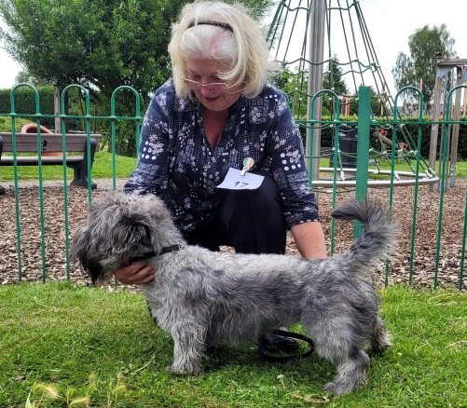 Orchard Burrow Oakley  
  
1st Majors - Orchard Burrow Oakley (D)   
1 year old blue dog of nice size and shape. Nice head, ears and eye. Correct scissor bite. Good rib and topline and carried his tail well. Nice harsh coat. A bit lively but walked okay in the end  
  
2nd George’s - Romainville Rock on Rosie (B)  
Promising blue bitch with many good attributes. Good head and features, clean bite. Deep chest with a well sprung rib Level topline rising to the loins. In good coat. Walked well. 1st won on maturity  
  
3rd Boudivella Fire Cracker  
Res: Weir Mead Susie  
VHC: Llaisafon’s Raya  
  
Special Award PG D/B 6/6  
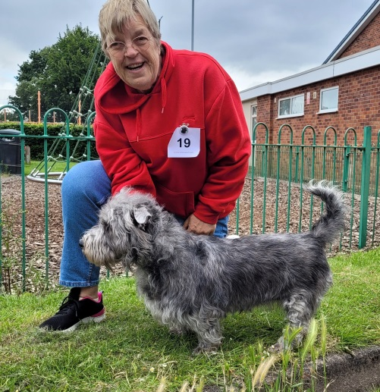 Boudivella Maisie  
  
1st Pierce’s - Boudivella Maisie (B)  
Delightful blue 2 year old girl. Good feminine headpiece, neat ears. Good pigmentation all round. Correct bite. Good height to length ratio. Powerful quarters. Great harsh coat, Walked well. Perhaps needs a bit more coaxing to get the best out of her, but a very nice girl indeed.  
  
  
2nd Howarth’s - Amhard Sugar Plum (B)  
Wheaten girl of a nice size and shape. Good broad laid back shoulders, Level topline. good rear angles. Good bite and head features. A very lively and happy girl but moved well when required   
  
3rd Amhard Runrig  
Res: Boudivella Arlo  
VHC: Romainville Blue Indigo  
   
Special Award Open D/B 6/5  
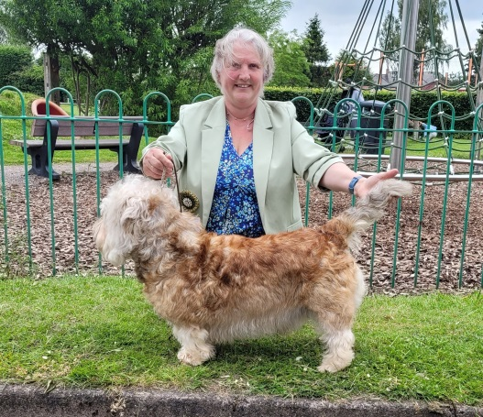 Ch/Ibnt/bel/ch/nl/esp CH Boudivella Oscar Vw  
  
1st Hannington’s - Ch/Ibnt/bel/ch/nl/esp CH Boudivella Oscar Vw  
Impressive Wheaten dog of a grand stature. Great powerful head, good eye and ear carriage. At nearly 10 I allowed for an aging mouth. Broad shoulders well laid back. Strong rear end with a good bend of stifle. Very well balance dog which covered ground with ease and drive  
  
2nd Bailey’s - Zippor Brendan (D)  
I’ve admired this wheaten boy before. Good strong head, good eye and ear carriage. Well sprung rib. Nice rising topline, Good rear angles, great coat, walked well. Bite could be better but a very nice boy nonetheless   
  
 3rd Amhard Quick Sand  
Res: Amhard Mai Tai  
VHC: Llaisafon’s Raya